# UNIT 1

## History, Methods, Content of IO

### INTO Questions

Q: Why do organizations exist?

A: extend the human’s capability (accomplish a goal that individuals cannot)

Q: How do organizations make decisions?

A: data-driven science

### Defining IO(Industrial and Organizational) Psychology

#### Objectives

##### Science

Individual difference: separate people into groups (EG. some is successful and others are not?)

General characteristics: men and women

##### Practice

relevant to me

relevant to my employer

#### Methods

##### Research Process

Formulation of the problem

Generation of hypotheses(specific statement about the relationship among the variables in the study)

Choosing of a design

variable types:

independent(property of the object)

dependent(performance)

mediating(independent => mediating => dependent)

moderating(affecting the relationship “=>” in independent **=>** dependent)

extraneous(variables that are not in the study)

##### Data Collection

Experiment(most innovation)

sampling from population(hopefully random)

hypotheses or research question

treatment and control groups

random assignment to groups

Quasi-Experiment:

* not randomly assigned to treatment/control groups(ex. educational research teachers/students cannot be randomly assigned to different classrooms for research purpose)

Naturalistic Observation

Survey Research(most natural)

##### Data Analysis

Descriptive Statistics: only describing the outcome

Inferential Statistics: prediction + probability

Bayesian Statistics: applies probabilities to statistical problems (EG meta analysis)

##### Reporting/Interpreting Findings

Small Research Groups

Professional Meetings

Technical Reports

Research Journals

Books, Book Chapters, Text Books

##### Limitations

Some questions hard to examine

Observation can change behavior

Lack of generalizability of findings

#### Content

##### Personnel/Industrial Psy

Job Analysis: how do people describe the work

Job Design: how to determine the job

Employee Selection: who gets what work

Employee Training: training and evaluating

Job Performance: how to measure who is doing the job

##### Organizational Psy

Worker Motivation: what and why motivates work

Work Attitudes: survey about the work, organization, goal to understand why like/dislike

Workplace Communication: what to say/not to say

Leadership and Power: who is and what makes a good leader

Organizational Theory: why this structure/organization work

##### Engineering/Human Factors Psy

Workplace(chair, lying, color), Tools, Machines, Software, Displays, Controls

##### Consumer Psy

Consumption Behavior: why some buy certain products

Desirable Product Features: how to make product desirable

Impact of Advertising: what and who to advertise

Pricing and Perceived Value: 39.99 is much better than 40

#### History

##### Early Beginnings

Psy in lab => used in real world (inform to practice)

##### WW I - Personnel Psychology

two tests for people who don’t know how to read/write

application of IO Psy -> selection problem

##### Hawthorne Studies

industrial evolution: telephone => study focused on products

conclusion(**Hawthorne effect**): people tend to work harder when involved

##### WW II - Engineering/Human Factors Psy

machine => design of workplace, machine, tools...

##### 1960’s - Organizational, Consumer Psy

size, complexity of the organizations increased exponentially => how to control

##### 1990’s - Information Age, Virtual Organizations

internet, virtual interaction =>

### Doing IO Psy(practical model)

Practice(RELQ) = Location + Role + Qualifications + Evaluation(EG. APA APS)

Science = View of Science (Applied/Basic) + Location of Research (Field/Lab) + Limitations due to subject of study

### Models in IO Psy

#### IOIE Model

Environment = external + organizational + work

Individual = KSAO

Knowledge

Skill

Ability

Others(personality)

Organization = communication + group & teams + leadership + organizational theory

Interaction = personnel PSY(job analysis + selection + training + performance evaluation)

#### Behavior Model

= MAKE(motivation + ability + knowledge + environment)

Integrated HR System Model

#### The Interaction between people and the organization

Multiple activities

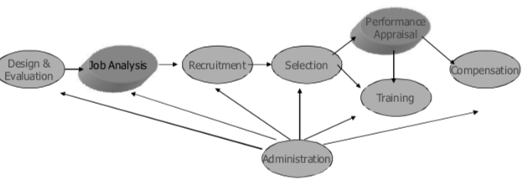

Multiple outcomes

Job Performance

Withdrawal Behaviors

Absence

Tardiness

Turnover

Attitudes

Disputes

Interdependence

Output is Input

Failure in one area affects all areas

Repeating Cycles of Events

Two “Super Functions”

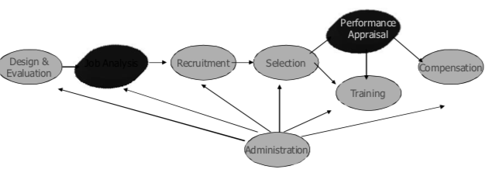

“Family Tree”

Wundt = 1st psychologist scientific study of behavior

Pintner and Arps

Paterson

Dunnette

Hakel

Wilson

### Experience of Science and PSY

## The Organizational Context

### Types of Environments

External Environment: culture, politics(regulations => take more risk), economic(bank), tech(automation), physical(living location)

| Culture | Politics | Economics | Tech | Physical |
| --- | --- | --- | --- | --- |
| Collectivist vs. Individualistic | Legislation | Globalization | Digitalization | Geology |
| Homogeneous vs. Heterogeneous | Regulation | Labor market | Internet, broadband network | Natural resources |
| Tolerance vs. Conformity | Litigation | Productivity | Information System | Climate |
| Democratic vs. Autocratic |  |  | Nano tech |  |

#### (External)Politics - The Public Policy Cycle

Legislation(law gets passed, attempt to enforce the law)

Regulation: clarify the application of the law(Uniform Guidelines), challenge the meaning of the law

Discrimination definition

Evil-Intent

Unequal treatment

Adverse Impact = negative effect on a group of people

Selection Ratio =

4/5ths Rule =

* less than 80% => adverse impact

Test = any barrier between employer and applicant in the job

Availability Analysis

Workforce Availability =

* total size is estimated

Utilization =

* Utilization < Availability => affirmative actions
* Be aware of very small/large labor pool

Litigation: does this new law violate some constitutional principle

EG. poison pill. strategy to prevent other companies(acquirer) from being taken over

EG. Griggs vs. Duke Power Company: adverse impact + job relatedness

Prior Discrimination was not disputed

New Selection Criteria after CRA

2 Tests (Wonderlic & Bennett)

High School Diploma

New Education Benefit

District Court Findings:

Discrimination has stopped

Prior Discrimination beyond reach

Appeals Court Findings:

Prior Discrimination not insulated  
New Hires must meet new standards

Supreme Court Findings:

Results not intent “adverse impact”

Standards must be “job related”

Major Legislation, CRA

Defines Prohibited Acts: discharge, segregate lower/higher based on classes

Defines Protected Classes(race, religion, color, sex, national origin)

Includes Tower Amendment: an unlawful employment practice for an employer to give and to act upon the results of any professionally developed ability test

Organizational Environment Types:

Production: makes/provides the product/service

Maintenance: enforces organizational rules and maintains stability and predictability

Boundary: deals with procurement and disposal of raw materials, technology and products/services

Adaptive: does planning, research and development

Managerial: control, coordinate and make decisions

Work Environment

| Dimensions | Demands | Outcomes |
| --- | --- | --- |
| Variety多样性 | Emotional | Goals |
| Identity | Interaction | Expectancies |
| Significance | Physical | Habits(automatic response) |
| Autonomy | Skill | Needs |
| Feedback | Knowledge | Values |
|  | Production | Rewards |

### Environmental Characteristics

Stability-Turbulence

Uniformity-Diversity

Organized-Random

Munificence-Scarcity

Controllable-Uncontrollable

### Organizational Reactions to the Environment

Direct Control

Indirect Control

Slack Resources

Restructure

Form Alliances

## Design and Analysis of Jobs

### Job Description

#### Definition of Job Analysis

Collecting Information about Jobs

By any Means

For any Purpose

Single Purpose: more common EG. advertise, selection

Multipurpose: trade-offs EG. military tank designed to meet multiple purposes

#### Decisions to make in job analysis

Level of Analysis/Degree of Specificity

| Degree of Specificity | Numbers |
| --- | --- |
| Occupation(grouping of related jobs) | 1000’s |
| Job(abstraction of position) | 10’s-100’s |
| Position(from elements to job dimensions on one person) | 1 |
| Job Dimensions(theory of the nature of the work) | 10’s |
| Duties(grouping related tasks, more organization related comparing to Job Dimensions) | 10’s |
| Tasks(units of work) | 100’s |
| Elements(movements EG. Time and Emotion ) | 1000’s |

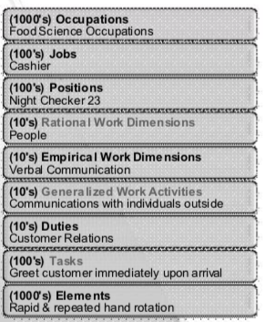

Source of Information

Incumbent

Peers

Supervisor: some concerns, may not know the details

Subordinate: only know their work

Analyst: people behave different things when being watched

Mode/Form of information collection

Interview

Observation

Participation work with them => get internal insights, but may interpret as false insight

Survey

Diary

### Evaluation Criteria

Acceptability: accepted by supervisor

Utility: useful

Shelf Life: how long this information last? more specific => last shorter

Reliability: not about right/wrong; about redesign the job title

Validity: confirm it’s right

IPS Model

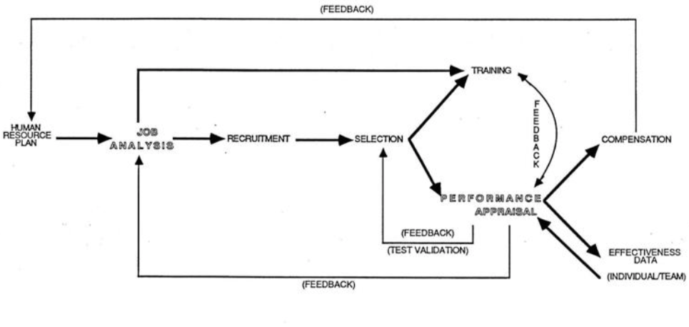

Work-oriented: activity of the work

Worker-oriented: demand that the work places on the person

### Job Analysis System

#### Functional Job Analysis

Rational Job Dimensions: data, people, things

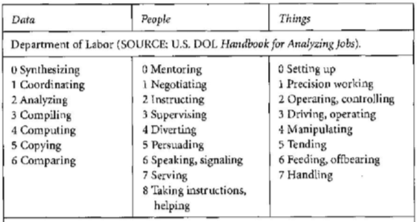

Makes use of Tasks

#### Ability Rating Scales

Behaviorally Anchored Rating Scales of

Cognitive Abilities

Motor Abilities

Perceptual Abilities

Tests Developed for each Ability(Ex. physical ability)

#### Department of Labor/DOT-O*Net

Originally included a job schedule with

Summary: abstract and descriptive

Work Performed Ratings

Trait Requirement Ratings

Tasks and Work Environment Description

Now much more general set of dimensional ratings on less specific occupational groups

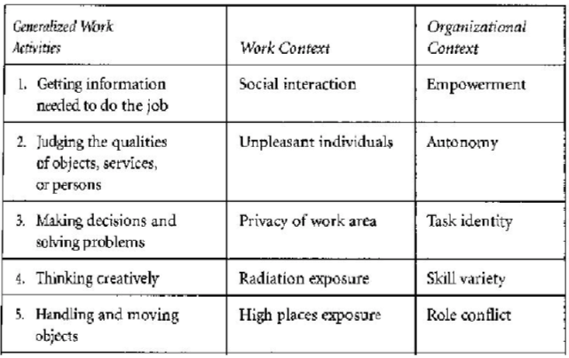

#### CODAP

Inventory of Job Tasks for Multiple Jobs

Often Evaluated on Several Scales

Difficulty

Frequency

Time

Used to refine and align training: people don’t do the important things in training

#### Critical Incident Technique

Special Kind of Task Analysis

Tasks Related to High and Low Performance: closely related to Task Inventory

Useful for developing evaluation forms

#### Position Analysis Questionnaire

Based on a “Theory of Work”

Work Inputs

Work Processes Work Output

Meant to Apply to all or most Work Normative Data Collected

## Job Analysis

### Determine equity in pay

| Internal Equity / job grading | External Equity / labor market survey | Process Equity | Individual Equity / merit pay, or bonus |
| --- | --- | --- | --- |
| Different jobs in the same organization in terms of worth  May conflict with External Equity | The same job in different organization in terms of worth  Market based compensation can lead to large internal equity differences | About the fairness of the process used to determine wages  Feature: open/transparent  Subject to lots of individual variation for same process | Performance of the individual to others doing the same work  To recognize individual variation in job performance |

#### Determine internal equity

Examine entire Job

Job Ranking(ranks the job in the organization):

alternate ranking: best, worst, best, worst…

comparison ranking: compare each job with all the left (grow exponentially)

key job ranking: rank, description of the job, workload(standard table)

* not always objective.

Job Classification

Sort into categories based on the description of the job

Conflict: some parts sound like one class, other parts sound like the other class

Break the job into parts(some parts are not valuable while others are)

Point System: evaluate compensable factors and add points to determine the job

Good: more detailed and systematic(perceived to be fair)

Determining the points is arbitrary

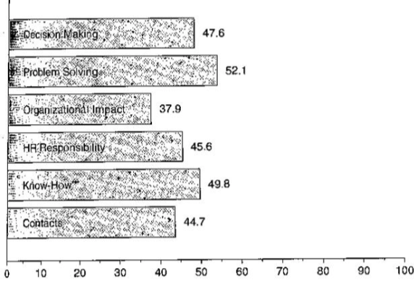

Factor Comparison

EG. Key Job A/B/C worth ….

Factors = skill + effort + work condition

All factors are equally weighted(can be differently weighted)

| Job | Skill | Effort | Work Condition |
| --- | --- | --- | --- |
| A($ 12000) | Low($ 4000) | Low($ 4000) | Low($ 4000) |
| B($ 18000) | Mid($ 6000) | Mid($ 6000) | Mid($ 6000) |
| C($ 30000) | High($ 10000) | High($ 10000) | High($ 10000) |

Benefit: persuasive

But: determine key jobs)

#### Determine external equity

Determine your labor market: local > regional > national > international labor market

the simpler the better <= larger labor market is associated with higher cost

Examine government data

not using government data <= not specific enough

* looking at the median salary data instead of the mean(influenced by the outliers)

Collect labor market information

illegal to share what the company plan to do(hire certain number of people)

### What happens when equities are different?

Problems with “looking inward” => internal equity

overlook at the internal equity and ignore the market => overpaying and less competitive

Problems with being market driven => external equity

comparing to the market => distracted and upset if underpaying

Focus on managing perceptions

what you do + how people perceive your job => fairness

* not everyone will be happy

### Legal issues in pay

Equal Pay = same SERW(Skill + Effort + Responsibility + Working Conditions)

EG. risk can be responsibility or working condition

Comparable Worth

Similar Points/Internal Equity

Essential Functions (ADA): only exclude the person when the disability prevents from performing the essential functions

### Discuss Job Analysis Research Study

Study Design(Research Question OR Hypothesis)

EG. how much this work worth? predict a wage? for this job, what are other jobs related? other variables in the research?

Correlational Design

Internal Validity: ability to make causal inference. How it avoids confounding

External Validity: how this research relate to the real world

Construct Validity: measures in the study are adequate

Statistical Conclusion Validity: ability to detect the differences in data

Participants

missing participants is always an issue in correlational study

Measures

PAQ(Position Analysis Questionnaire) used in this case

Independent(PAQ) & Dependent Variables(predicted wages)

Mediating & Moderating Variables(Socio-Economic Status, Education, Age)

Procedure: interview -> PAQ -> informal feedback from the interviewer

Analysis

Results

1. Patrolman 6.69

2. Home economist 7.95

3. Airport maintenance chief 9.96

4. Kitchen helper 9.99

5. Fire lighter 10.21

Limitations

Participants all came from one city

Participants may have inflated responses

Should have matched ability profiles as well as dimensions

Some data not reported (e.g., age and education data)

### Discuss Job Analysis Technical Report

Problem being addressed

JobDescription/Classification

Employee Selection

Employee Performance Appraisal

Job Design

Employee training

* For Job of Personnel Assessment Specialist

Specificity of information

Source of information

Source was job incumbents and SMEs

Modality was survey & interviews

No evaluation was reported

Modality of information

Develop + Administer + Analyze task survey

Develop + Administer + Analyze KSAO survey

Evaluation of information

Procedure

Results

### Compare and Contrast the two Documents

Similarities: about job analysis, based on the data collected from the survey/interview, jargon

Differences:

technical is much longer <= attach all the documents

research is more readable

Accessibility

Ability to Replicate

## Quiz 1-6 [Quiz Quizlet](https://quizlet.com/91390241/io-quiz-1-6-flash-cards/) & [Exam Quizlet](https://quizlet.com/118090611/psy-307-list-of-lists-exam-1-flash-cards/)

The four blocks of content in the course include all below except _____.

a. communication, groups, motivation & attitudes

b. power, leadership, organizational theory

**c. maco economics, process analysis, forcasting**

d. employee selection, performance, training & development

e. none of the above

Who was an experimental psychologist who became interested in IO Psychology topics?

a. Frederick W. Taylor

b. Hugo Munsterberg

c. Walter Dill Scott

**d. both b and c**

e. none of the above

All of the following are a part of the research process except for _______.

Select one:

a. interpretation of data

b. generation of hypotheses

c. collection of data

**d. recallebration**

e. none of the above

Which data analysis method is the basis of meta-analysis?

a. descriptive statistics

b. inferential statistics

**c. bayesian statistics**

d. estimation statistics

e. none of the above

## Quiz 2

All of the following are topics in organizational psychology except for _____.

a. worker motivation

**b. job analysis**

c. work attitudes

d. leadership and power

e. none of the above

Engineering/Human Factors Psychology is primarily concerned with _______.

a. design of the workplace

b. design of tools

c. design of software/UI

d. design of controls

**e. all of the above**

The army Beta test was designed during World War I to deal with potential soldiers who ___.

**a. could not read**

b. could not run

c. could not do push-ups

d. could not hear

e. none of the above

All of the following are part of the IOIE model except for _____.

Select one:

**a. Integration**

b. Environment

c. Individual

d. Organization

e. Interaction

The two super functions in the Integrated HR System are _______.

a. job analysis and compensation

b. training and compensation

**c. job analysis and performance appraisal**

d. administration and recruitment

e. none of the above

## Quiz 3

Which is not part of the public policy cycle?

a. legislation

b. regulation

**c. enforcement**

d. litigation

e. none of the above

Which one of the characteristics listed below is not part of the work environment as discussed in the lecture?

**a. global**

b. dimensions

c. demands

d. outcomes

e. all of the above

Adverse impact is defined by the _____?

**a. 4/5ths rule**

b. U.S. Department of Labor

c. U.S. Treasury

d. U.S. Department of Defense

e. none of the above

Griggs vs Duke Power established the legal notions of _____?

a. damages

b. adverse impact

c. job relatedness

**d. b & c**

e. none of the above

All of the following are types of environments discussed in the lecture except for _____.

a. external

**b. internal**

c. work

d. organizational

e. none of the above

## Quiz 4

A definition of job analysis includes all of the following except _____.

a. collecting information about jobs

b. by any means

c. for any purpose

**d. limited to a single purpose**

e. none of the above

Levels of specificity in job analysis include all of the following except ______.

a. elements

**b. parameters**

c. position

d. job dimensions

e. duties

The potential sources of information in job analysis are _____.

**a. incumbent, peers, supervisor, subordinate, analyst**

b. incumbent, peers, supervisor, subordinate, competitor

c. incumbent, peers, CEO, subordinate, analyst

d. parents, peers, supervisor, subordinate, analyst

e. incumbent, tasks, supervisor, subordinate, analyst

All of the following are ways of evaluating job analysis results except _____.

a. validity

b. reliability

c. shelf life

d. utility

**e. None of the above; all are ways to evaluate job analysis results.**

The critical incident technique is most closely related which other job analysis system?

a. PAQ - Position Analysis Questionnaire

**b. task inventory**

c. O*Net - Occupational Network

d. ability rating scales

e. FJA - Functional job analysis

## Quiz 5

All of the following are types of equity except for _____.

a. external

b. individual

c. process

d. internal

**e. market**

Internal equity compares jobs _____.

**a. inside the same organization**

b. outside the same organization

c. to their market value

d. with their counterparts in other organizations

e. none of the above

Process equity is concerned with _____.

a. comparing jobs across organizations

**b. the fairness of the wage setting process**

c. comparing jobs within an organization

d. all of the above

e. none of the above

All of the following are methods of determining internal equity except for _____.

a. job ranking

b. job classification

c. point system

d. factor comparison

**e. none of the above**

The compensable factors relevant to the equal pay act include all of the following except for _____.

**a. decision making**

b. working conditions

c. effort

d. responsibility

e. skill

## Quiz 6

The purpose of the PAQ research study was to determine _____.

a. if the homemaker job could be analyzed with the PAQ

b. if a wage for homemaker could be estimated

c. if the homemaker job could be matched to other job profiles

d. if age or socioeconomic status was related to responses

**e. all of the above**

The type of validity that was most at risk in the PAQ study was _____.

a. internal

**b. statistical conclusion**

c. construct

d. external

e. none of the above

The homemaker profile in the PAQ research study was most similar to the _____ profile.

a. home economist

b. kitchen helper

c. firefighter

**d. patrolman**

e. none of the above

The job analysis of the personnel specialist job was useful for all of the applications listed below except for _____.

**a. compensation**

b. performance evaluation

c. employee selection

d. training

e. job description

How many jobs were identified using the cluster procedure?

a. 4

**b. 7**

c. 5

d. 6

e. none of the above

# Block 2

## Employee Selection

### Choose Org

Paradox of Selection process: Indv attracts Ogr and Ogr selects Indv. Ogr attracts Indv and Indv selects Ogr

Decision method => People have different styles

Aggregator: detailed in decision making and comparing(EG. time limited on job offer)

=> Ogr needs to know aggregators’ concerns

Satisficer: vague ideas about what they want

Expectations

Level of Experience: high expectation is not good => may make the person leave

Realistic Previews

people tend to exaggerate the positive side, and be overly positive about the job

### Measurement

Correlation [-1, 1]

EG. personality and football player score

Linear Regression

### Reliability

* reliability can usually but not always be expressed as correlation

A theory about scores

True score = real score. high reliability => closer to the true score

Error in measurement => score varies

Random Error uncorrelated over administrations (EG. random variable)

Fixed Error (EG. SAT’s topic/format)

test <= history+ situation(emotion, physical) + item selection

history EG. personality is usually very reliable and stable unless traumatic events happen

Three types

Test-Retest

Repeat the extract same measure after some time interval

Controls for the error due to situation

Vulnerable to historical effects <= history between the two tests

Sub-sample comparison

Examines the relationship among items (should be roughly the same)

Three types

Split-half, odd-even, item reliability(performance on items & performance on whole. Very huge difference => the item’s level is not the same)

Controls for error due to item selection

Vulnerable to situational effects

Parallel forms

Develop two unique forms of test

Can control for both items and situation

Expensive and hard to do

Can be vulnerable to history

### Validity

About the truth of inferences

Limited by reliability: it limits validity(doesn’t measure the right thing)

Face validity(whether the test appears to measure what it claims to) is important

Three types

Content validity(doesn’t involve correlation) = the extent to which a measure represents all facets of a given construct

Based on job analysis

Examines one measure at a time

Usually a professional judgment (does the content of the measure correspond to the content of the job?)

Important for face validity(usually higher)

Predictive validity = does predictor predict?

Examines the relationship between two measures

Can involve a time interval

Three types

Concurrent(use the existing employee => easier and common)

True Predictive(random select regardless the test score)

Mixed

* + missing range => no full variation
  + reduction of correlation <= restriction of range <= not true predictive studies

Construct validity compares the relationship between different measures of the same thing

The most complex and time consuming

Examines several measures of the same thing

Examines predicted relationships among constructs

What can limit validity?

Inappropriate selection device or performance measure

Who is being tested

Time interval between selection and performance measurement

Failure to understand individual differences or performance constructs

Problem and Validity

| **Problem** | **Answer** |
| --- | --- |
| Unreliable measures | Reliability |
| Inaccurate job description | Content Validity |
| Trait - Predictor mismatch | Construct Validity |
| Traits are not relevant | Predictive Validity |
| Criteria are incomplete | Content Validity |
| Range Restriction | Predictive Validity |

### Choose people

Predictions of future success <= ability + motivation + environment

Individual differences is the reason why we pick one rather than the other

Stability of measures related to the reliability

Placement(find a place where the person is the best) or selection(select people who fit into the position)

* placement is better <= job duties change

### Predict Success

Behavior samples (observable, and indicates the individual traits)

Traits (not observable)

Job specifications (not observable)

Criteria (observable, and indicates the job specification)

### Predictors

Interviews(hard to be standardized, and biased assumption)/Questionnaires/Observations

Background Predictors: focus on a person’s past

Formal Education: moderate validity (EG. general education is not so valid)

Training and Experience (EG. job training)

Biographical Information valid (EG. countries and certain parts of the country)

Job Knowledge Predictors: focus on relevant job knowledge

Job Knowledge Tests: not so valid <= knowledge doesn’t indicate being skillful

Job Samples: do the task and it’s highly valid

Job Simulations: highly valid and can add low-possibility events

(EG. The Special Case of Managerial Assessment Centers

First designed to select spies. Now widely used for managers

3 Key Parts

Multiple relevant evaluators

Multiple dimensions of performance

Multiple Exercise)

Individual Attribute Predictors: focus on relatively stable traits of people

General ability (“g”): some always performs better than others regardless of the tests(IQ)

consistent relationship between general ability and work performance

Specific ability (“s’s”): cognitive(mental) + motor(movement) + perception(interaction)

specific physical requirements of the job

Personality (“p”): very consistent and stable(change is not common)

Big Five Personality: Openness to experience, Conscientiousness(higher score => higher job performance), Extraversion, Agreeableness, Neuroticism

How to Combine Predictors?

Compensatory Models: put into some matric and add them all(care the overall performance)

Multiple Hurdle Models: meet the minimal cutoff before going to the next test. BUT a person can do good on everything except one

Multiple Cutoff Models: take the test before determine the cutoff(mixture of the previous two)

It’s hard to determine the cutoff point

### Criteria

Test/Computer/Ratings

Training Performance

Job Knowledge

Job Skill (EG competitions)

Productivity

Citizenship Behavior (EG. help others)

### Impact of Testing

Usefulness: if it’s useful

First define success (EG. success = 4.5 or better on productivity)

Second determine cutoff score on the test (EG. cutoff = 175 or above)

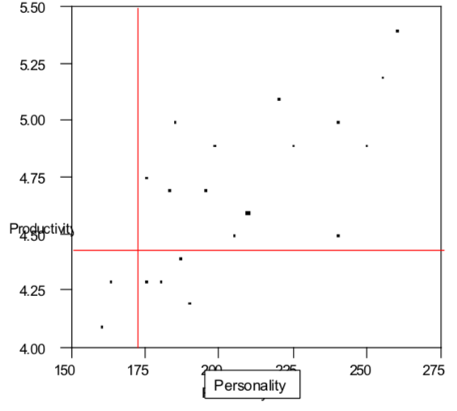

| False negatives  people you did not hire but would succeed | True positives  people you hired who did succeed |
| --- | --- |
| True negatives  people you did not hire and would not succeed | False positives  people you hired but who did not succeed |

Terms

Taylor-Russell Table

Base Rate can be improved by increasing test validity and decreasing the selection ratio

Data in body of table is expected percent successful

Base rate up => valid selection down

Selection ratio up => valid selection down

Validity up => valid selection up

Bias: is the selection process unfair

Moderator model (EG. look at the correlation of the sub groups)

Fairness model

## Employee Performance

### Purpose of the Evaluation

Decision Making : performance => action/decision EG do you get a raise/promotion?

Development : want the employees to get better

Human Resource System Evaluation : the purpose of selection/training/recruiting system is to improve job performance

* Relationship among Purpose of Evaluation

decision making & development focus on individual

individual => HRS evaluation system

* Information for DM can differ from the infor for D(usually more information needed)

EG. promotion DM only needs the top ranking. D needs more specific and behavioral details.

* … tank = achieving several purposes at once can cause conflict (focus on one specific purpose)

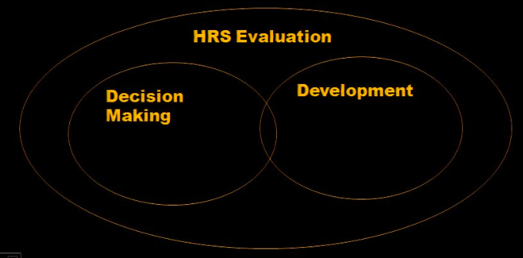

### What do we evaluate

#### Determine the Criterion

Ultimate = Dollar value of Performance (EG. how many less dollars if sb didn’t work here)

Equations are based on assumptions. not so accurate

EG. may lose employees whose value is underestimated if only care about ultimate

Dimensions = One or more for each major duty of the job

similar to the job analysis(breaking down into parts and add the values together)

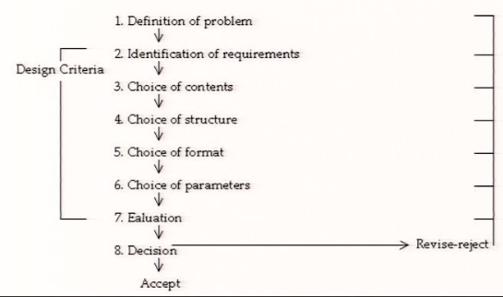

* Requirement for Criteria

Reliably measurable = Should measure behaviors and outcomes in an objective way

Content valid = Rationally related to the job performance activities

Defined specially = Important behaviors and outcomes should be included in a comprehensive criterion(EG. sb has bad attitude. What is bad attitude?)

Independent = Important behaviors and outcomes should be included in a comprehensive criterion (the independence between the criteria)

Non-overlapping = Criteria should not overlap

Comprehensive = No important behaviors or outcomes should be omitted

Accessible = Criteria should be phrased and name in a way that is comprehensible (easy to understand)

Compatible = Criteria should fit in with an organization’s goals and culture (EG. call speed and satisfaction level)

Up to date = Criteria should be regularly reviewed in response to organizational change

* Use of Criteria = goal of criteria + definition + measurement + common unication

measuring performance is not accurate => why to use to make the decision?

* Evaluation of Criteria

Criterion Relevance: relate to the duties

Criterion Contamination: include sth inappropriate (EG. what can contaminate the performance?)

Criterion Deficiency: leave sth important out

Criterion Usefulness: serve the purpose

#### Description or Evaluation(compare) of Performance

Description involves less effort: no decision making

Description can reduce errors and bias: only describing the facts

Description enables consistent analysis

Description can include several players: evaluation is more centralized

Description reduces power of manager <= no decision making

#### Setting Standards for acceptable performance

Absolute = fixed and applied to everyone (EG. A = 90+)

Normative = compared in a group and group performance matters (EG. A = top 10%)

* combine?

#### Objective or Subjective Measures

Objective measures?

Production measures = quantity

EG. Typist – Lines per week; Logger – Cords of wood cut; Wood harvester – Number cords delivered; Tree planter – bags of tree seedlings planted

Quality Measures (check the error rate to prevent bad things from happening)

EG. Service Representative – errors in processing customer orders; Clerk – errors per 100 documents checked; Dentist – errors in reading radiographs; Helicopter pilot – deviations from proper instrument readings

Dependability Measures (reliable?)

Attendance

Extensive use of Sick Leave

Tardiness

Volunteering

* Problem with Objectives Measures

Not available for all jobs(hard to count)

Often deficient(quality can vary a lot)

Hard to diagnose problems (know the data but don’t know why)

You get what you count (may relate to sth negative)

Can increase headcount

Not always relevant

Subjective measures

Ranking

Simple: rank by performance but hard when population is too large

Alternate: best, worst, best, ...

Paired Comparison: compare two and pick the better one. Highest pick = best, but doesn’t work so well when population too large

* no equal difference between 1-2 and 2-3

Forced Distribution: Defined Performance Categories(fixed number in each group)

* may have more/less high-performance employees
* ranking and forced distribution is good to give limited resources

Graphic Ratings

“On a scale of 1-5” EG. teaching evaluation

RQ f (I, S, M) rating quality = f(form/instrument, skill, motivation)

skill = if they have observed(performance rating <= knowledge about the person, knowledge about the process)

motivation: motivation is not good and person is not honest

* Evaluate the rater (EG. reward raters if they do a good job)
* Behavioral anchored rating scale:
  + collect the data about the good employee and bad employee
  + summarize the good employee and bad employee
  + give description along the scale

Behavioral Checklists:

Scale no longer visible to rater => see the inconsistency in people’s behavior

EG. frequency, quality

Can check for “errors” and gives feedback about what to improve

Problem with Subjective measures

Can vary dramatically

Raters need training

Raters need motivation

Raters do not like doing it

Assumes what you are trying to measure

### Who does the evaluation?

Supervisor : bias => may not be the best source

Self

Peers :

Subordinate : supervisor needs to make hard decisions and subordinate doesn’t see the bigger picture

Other

How to pick a source?

Each has drawbacks

They may have different information

Supervisor makes ultimate decisions

Purpose is important

Use multiple sources (no one perfect source)

### Giving Feedback

Should be descriptive

Should be specific

Should be appropriate/needs bases

Should be directed towards changeable behavior

Should be recent to events discussed

Should be honest

Should be understood by both parties (examples are good)

Should be proactive and coactive with specific directions for change and agreed upon action plans

Should not be used to criticize or find fault and should be common/uneventful

### How do you evaluate performance evaluation?

Bias : hard to detect the pattern in one time period.

Contamination : job description and what the person is doing (EG. life)

Deficiency : job analysis helps

“Rating Errors”

Distribution Errors : relate to frequency

Leniency(rate everyone around top), Central Tendency(average), Severity(bottom)

Halo Errors : relate to emotions (EG. grade all 5 to people who you like)

Contrast Errors : depends on the group you are working with

## Training & Development of Employees

### Training Abuse Cases

Training Cases

Medium Manufacturer(Exit interview)

Problem: Exit interviews indicated poor supervision

Solution: Sensitivity Training (interpersonal training: your behavior impact others)

Real Problem: Jobs had changed (<= situation becomes more complex)

Solution: New Selection System

Large Insurance Company(Outcome/performance)

Problem: Sales declined after merger

Solution: New Sales Pitch Training

Real Problem: Benefits & Supervision

Solution: Restored both (bring the old supervision and pitch training)

Small Manufacturer(Worker attitude)

Problem: Low worker moral(not positive)

Solution: Company History Training

Real Problem: Low cost producer

Solution: Delete Moral from Report

Why is Training Abused? training is not the solution to all things

It looks fast and decisive (offered by others)

Puts the blame somewhere else (supervision/worker)

No change for organization (requires the employees to change)

Real problem avoided (managers usually know the real problem but it can be hard or time consuming to deal with)

### Discussed the steps in a training program

Models

IOIE model: Interaction = Job Analysis + selection + **training** + performance evaluation

Integrated HR system: multiple activities also include **training**

Steps

Assessment Phase to figure out we need training

Training and Development Phase to execute training

Evaluation Phase to figure out how well it worked * always left out by organizations

Expanded view of steps

Assess training needs

Establish training objectives

Develop and test training materials

Implement training program

Evaluate training program

### Assessment Phase

Organizational Analysis: skills needed by organization, organization strategies(hard and secret)

Operations Analysis: skills needed to operate the task

Human Analysis: how to make sb to be a better performer?

Questions: bad performance + personal reason + lack of skill => training needed

What’s the person’s performance? good => no operation/human training needed

Is the lack of performance due to the person or a natural circle? natural circle => no training

Is the lack of performance due to lack of motivation or skill? motivation => no training

### Learning Principles in Training

Reinforcement: positive = add reward negative = remove punishment

Feedback(can be reinforcement) and Goal Setting(encourage future participation)

Shaping(gradually shaping wanted behaviors) and Modeling(show a model)

Eg. reward: toward the piano -> touch the piano -> touch in certain order

Practice (break big practice into small pieces because the brain needs time to reorganize)

Transfer of Training

mental rehearsal: knowledge into practice

law of identical elements: as close as the work environment

overlearning to let behaviors be default/automatic

Applied Training Principles:

train the person in a way the job is performed

start from the easiest -> perform all in the right order

### Presentation Techniques

On-the-job

Job rotation: cross training

Internship: expose them to the organization and not so committed

Mentorship: pair junior and senior to develop organizational skills

Problem with on-the-job

Hard to implement (time consuming, error in training)

Motivation of Trainer <= not want to be replaced

Can be very costly (hidden cost)

Trainers time

Trainers skill as trainer

Lost production

Off-the-job

Lecture: BUT it depends on individual’s learning pace and lecturer’s style

Good lecturer gives extra infor + interacts with the audience to engage people

Audiovisual

Firming a lecture is more flexible and gives the learner more control(low interaction)

Programmed: learning materials in a graded sequence of controlled steps

EG. learning objectives in each block → quiz → determine if go on or stay

Personalized way = choose the material to be presented and tested

Computer-assisted system = make suggestions about the material and learner decides

BUT may interrupt learning

Simulation: perform the tasks, especially high-risk ones, in a simulated protected environment

Fidelity: does the simulated the same as the real environment?

physical fidelity is feeling real

psychological fidelity = person is in the same psychological state

* Ways to increase fidelity: longer time; rapidly switching between tasks

BUT expensive to simulate physical fidelity

Conference: learn in a social setting by networking

Exposed to lots of information, BUT specific questions are not answered

Case: mental version of the simulation (EG. facts → problem → ask question)

more relevant => more attractive

Role Playing: good when teaching sb unusual interpersonal skills (EG. new skills + behavior)

Modeling: learn from observing others’ behavior

key behavior + role playing + social reinforcement(peer)

making plans for future use in the workplace

BUT it’s time consuming and expensive

Problem with off-the-job

Costs: we should compare the cost of training and the cost of not doing training

Time

### Method of presentation

Decision tree method: decide the training based on answers to the questions

Learning styles method

convergers(take abstract ideas → solve practical problems) => case

divergers(experience → look at it from different angles) => simulation, case, lectures... combined

assimilators(take abstract ideas and organize them, visual learner) => lectures, sometimes cases

accomodators(action active learners) => give them tasks

* people usually have a preference about the learning methods => training becomes even harder

### Evaluate Training

Determine criteria

Pretest trainees

Monitor program

Posttest trainees

Type of Training Evaluation Criteria

Reactions: do people like it or not?

Learning: giving test to examine how much they know

Behavioral: does the behavior change?

Results: outcomes. Do they perform better?

Training Evaluation Design: (pretest →) training → posttest

Control Group Design: in case some environmental impact exists

pretest → training → posttest

pretest → posttest

## Quiz 7-13 [Quiz quizlet](https://quizlet.com/192083594/psy-307-quizzes-7-13-flash-cards/)

Aggregators need ____ to make up their minds.

a. lots of information

b. time

c. clear understanding of their needs

**d. all of the above**

e. none of the above

_____ controls for error due to situation and is vulnerable to history effects.

**a. test-retest reliability**

b. sub-sample comparison reliability

c. parallel forms reliability

d. none of the above

e. all of the above

The less deviation from the regression line the _____ the correlation.

**a. higher**

b. lower

c. more negative

d. smaller

e. none of the above

The paradox of selection is that ___

a. both organizations and individuals are trying to attract

b. both organizations and individuals are trying to select

**c. what is done to attract makes selecting harder**

d. all of the above

e. none of the above

There is a type of validity that is _____.

a. based on job analysis

b. examines one measure at a time

c. based on professional judgment

d. involves face validity

**e. all of the above**

## Quiz 8

Assessment centers have multiple _____, _____, and _____.

**A. Dimensions, exercises, evaluators**

B. Evaluators, performance factors, raters

C. Dimensions, evaluators, performance factors

D. Exercises, dimensions, behavior samples

E. None of the above

A company uses a manual dexterity test to hire people; it is discovered that manual dexterity is not related to success on the job. This indicates a problem with _____.

a. reliability

**b. predictive validity**

c. content validity

d. face validity

e. all of the above

People who would have been successful but are not selected are called _____.

a. false positives

**b. false negatives**

c. true negatives

d. true positives

e. none of the above

False positives are people who _____.

a. would have been successful but were not hired

b. are successful

c. are not successful and were not hired

**d. who were hired but were not successful**

e. none of the above

False negatives are _____.

a. the percentage of people hired

b. the percentage of people interviewed

c. the percentage of successful people

d. the percentage of unsuccessful people

**e. the percentage of people who would have been successful had they been hired**

## Quiz 9

The primary purposes for performance appraisal are _____, _____, and _____.

a. decision making, development, review

**b. human resource system evaluation, decision making, development**

c. development, training, decision making

d. decision making, promotion, human resource system evaluation

e. none of the above

"Objective criteria" tend to focus on _____.

A. Work process

B. Work inputs

**C. Work outcomes**

D. Diagnosis of performance problems

E. All of the above

In comparison to subjective criteria, objective criteria are more likely to be _____.

A. Biased

**B. Deficient**

C. Relevant

D. Reliable

E. All of the above

Focussing solely on production (output) measures may lead to problems with _____.

**A. Product quality**

B. Product quantity

C. Productivity

D. Work process

E. None of the above

A supervisory rating of an employee's performance would be an example of what kind of criterion?

A. Deficient criterion

B. Subjective criterion

C. psychological criterion

D. Personal criterion

E. All of the above

## Quiz 10

The forced distribution rating system does not have a problem with which type of common rating error?

a. halo

b. central tendency

c. severity

d. leniency

**e. all of the above**

Rating quality is a function of _____, _____, and _____.

a. rating form, rating instructions, motivation of rater

**b. motivation of rater, rating form, skill of the rater**

c. skill of the ratee, motivation of the rater, motivation of the ratee

d. rating form, rating procedure, motivation of the rater

e. none of the above

A problem often present in having someone from outside the organization evaluate performance is that they do not see ______ performance.

a. lunch time

**b. typical**

c. summer

d. maximum

e. none of the above

The tendency of a supervisor to let his/her overall impression of an employee influence ratings of the employee on specific performance dimensions is called _____.

a. contrast error

b. central tendency error

**c. halo error**

d. proximity error

e. severity error

The tendency of the supervisor to avoid assigning high or low ratings to employees is called _____.

**a. central tendency error**

b. leniency error

c. halo error

d. severity error

e. none of the above

## Quiz 11

Which of the following techniques tends to be over used by managers?

a. selection

b. job analysis

c. performance measurement

d. attitude measurement

**e. training**

Which of the following should play the largest role in training needs assessment?

**a. organization analysis**

b. pretest-posttest design

c. test validation

d. principles of learning

e. all of the above

To determine if a person needs training you should ask yourself _____.

a. is there a disparity between what performance should be and what it is

b. is the disparity serious or part of a cycle

c. is low performance due to lack of knowledge or lack of motivation

**d. all of the above**

e. none of the above

Reinforcement _____ the probability of a response.

a. decreases

b. stabilizes

c. extinguishes

**d. increases**

e. none of the above

The importance of teaching tasks in a particular order is called _____.

**a. sequencing**

b. serializing

c. ordering

d. randomizing

e. all of the above

## Quiz 12

One potential disadvantage of off-the-job training is _____.

**A. Costs**

B. Lack of trainee motivation

C. Lack of fidelity

D. Lack of participation

E. None of the above

Which of the following jobs would be the most likely candidate for simulation training?

**A. Airline pilot**

B. Carpenter

C. Plumber

D. Insurance sales

E. School teacher

Kolb's learning styles included all of the following except

A. Convergers

B. Divergers

C. Assimilators

**D. Equivocators**

E. None of the above

What is the most effective procedure for evaluating a training program?

**a. experimental design**

b. post-test design

c. before-after design

d. quasi experimental design

e. none of the above

To have a true experiment you must have _____.

a. random assignment and post-test

b. post-test and control group

**c. random assignment and control group**

d. pretest and post-test

e. none of the above

## Quiz 13

The best definition of a meta-analysis is _____.

a. compilation of studies

b. an average of results

c. best estimate of effect

d. inherently bivariate

**e. all of the above**

Which test from the meta-analysis results should not be considered for use in selection of employees?

a. mechanical principles

b. finger dexterity

c. intelligence

**d. spacial relations**

e. none of the above

Range restriction results when _____.

a. top performers are missing from the data

b. low performers are missing from the data

c. some part of the distribution of test scores is missing

d. the entire distribution of scores is not included in the analysis

**e. all of the above**

The ____ validity was better than the ____ validity in the SAT Writing Test Validation Study.

a. incremental/predictive

**b. predictive/incremental**

c. construct/content

d. predictive/construct

e. content/predictive

The biggest problem with the SAT Validation Study was the _____.

**A. Return rate**

B. Incremental validity

C. Sample size

D. Predictive validity

E. None of the above

# Block 3

## Communication

communication is about conflicting of the decision, goal...

### Organizational communication Def

Passing Information

Micro(org communicates with its environment. EG Branding) and Macro(communication inside the org)

Levels of Analysis

Elements

Flow

Barriers

#### Elements

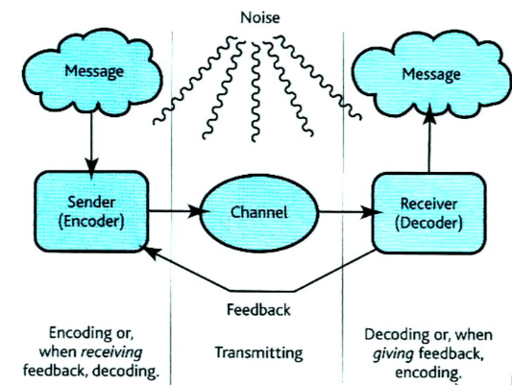

Sender(Break into pieces might be helpful)

status EG more likely to read message from boss rather than friends

credibility, skill at encoding

Message: Good or bad, complex(in graph) or simple, information or request(more interested in response)

(Source Factors

Status of the Source

Credibility/Believability of Source

Encoding Skills of Source

)

Encoding Mode EG telephone, face-to-face(good at feedback), meetings, memo, written report, teleconference, eMail

Encoding Language: message can be misinterpreted => miscommunication

same language means differently EG. “you are safe” => actually not

mortality varies in different forms EG spoken, written, unspoken, jargon(professional)

Channel = transfer vehicle

Route taken, each route has both Formality and Capacity

Receiver

Attention, perceptual ability, relationship to sender, decoding skills

Decoding

**Attention**, active listening(involved by questions, clarification)

Feedback: not always there.

Acknowledgement, clarification

Noise: other communication, multitasking

(Audience Factors

Attention span and perceptual abilities: varies in different groups

Relationship to sender: skills and languages of the sender

Decoding skills of receiver

)

#### Information Flow

Flow(complex network instead of a hierarchy)

Direction

One way, two way, open

Downward

upward

Lateral

Networks through which information flows

Increasing upward flow

Suggestion System(provide suggestion and concerns)

Grievance System(don’t like certain things and request a change)

Subordinate Appraisal of Supervisor(subordinate evaluate the performance of their supervisor)

Open Door Policy(difficult in practice)

Employee Surveys(about attitudes)

Participative Decision Making(communication increases)

Nonverbal Communication

Facial expressions, gesture, tone of voice, body movements, posture, style of dress, touching, physical Distance between Sender & Receiver(cultural differences)

(Chain flow network

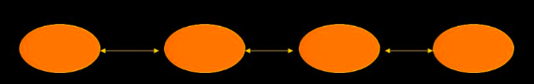

Y Flow network(one person at the center)

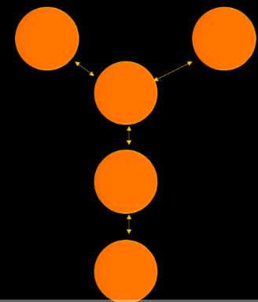

Wheel flow network(central power)

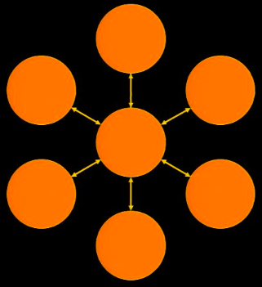

circle flow network

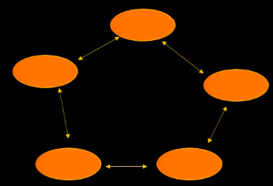

all-channel flow network(all the time spent on communicating)

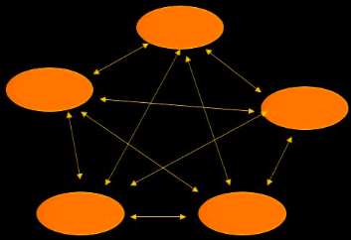

)

#### Barriers

Censoring: not communicating and not telling the truth

Filtering: communicating certain parts but leaving certain parts out

Diversion/Reroute: change channel => usually less response/attention

Interference/ Noise EG. multitasking

Overload EG. only certain # of calls can be processed

Priority(what gets priority?)/Exaggeration/Distortion

Why is Communication such a problem?

Informal rules or norms work against it(casual => approachable)

May be due to intense competition(defensive in competition => reverse message)

Tendency of People to be Defensive

Under communication due to the assumption that others understand us without checking(don’t assume self as a good communicator and make sure to ask questions)

## Groups

### Definition

= 2 or more people engaged in social interaction for the purpose of achieving some goal

| Formal Worker | Informal Worker |
| --- | --- |
| created by the organization  can be permanent or temporary | created by organization members  focused on common interests |

### How do you study work groups?

Participant observation (how to know who participate?)

Surveys

Sociometry(what does everyone think about each other)

“+” to indicate “High Trust”

“O” to indicate “Moderate Trust”

“-” to indicate “Distrust/Conflict”

### Purpose of a work group

Set Norms(general rules, guidelines)

Define Roles(specific person)

Group Task Roles(roles must be taken so that the group is able to perform)

Initiator-contributor, information seeker or giver, opinion seeker or giver, elaborator, evaluator, etc.

Group Building and Maintenance Roles(makes sure the group is functioning well)

Encourager, harmonizer, compromiser, gatekeeper, standard setter, observer, follower

Self-Centered Group Roles(serve their own interest instead of the group interest)

Aggressor, blocker, recognition seeker, self- confessor, playboy, dominator, help seeker, special interest pleader

Participation: maybe the reason why humans survived and stood up.

Social Interaction

Social Influence

Information

Job, Policy, Procedure, Mission

Communication

Cohesion: forming a united whole

Problem Solving

Decision Making

Conflict

Groupthink

8 symptoms: illusion of invulnerability/morality/unanimity, shared negative stereotypes, collective rationalization, self-censorship, direct conformity pressure, mindguards

| pros | cons |
| --- | --- |
| Broad knowledge base  Decision is accepted by members  Decision is highly critiqued to point out the negative side  Aspects of the problem can be divided among group members | Slow  creates intragroup conflict  Potential for groupthink and group polarization  Certain members dominate the decision making process |

Rules of brainstorming: diagnose the problem(can be critical) → find the potential solutions(no criticism, as much as possible) → evaluate the solutions(cost, time…)

No idea is too far out: be as creative as possible

Criticism of any idea is not allowed

The more ideas the better

Build on each others ideas(interaction of the ideas)

### What are group processes?

### Organizational Conflict

Definition

Incompatible goals => aggressive behavior, negative interpersonal perceptions, hostile feelings

Can occur at several different levels

Intrapersonal within individual(working and relaxing)

Interpersonal between people

Intragroup inside the same group

Inter-group/intra-organizational among different groups

Inter-organizational among different organizations(<=competition)

Conflict Process

Antecedents: history => natural cycle

Issues in design, in actors(individuals) EG what’s the incompatible goal

Parties: different groups of people with different opinions

Interested Audience depends on the conflict. Can be outside the org

Strategy and Tactics: how to feel the conflicts. Depends on the style and org

Consequences: winners and losers

Predicting the Conflict Process

Examine links between parties

Links between parties goals

Independent VS Interdependent

Links can be of two types

Positive(win-win) VS Negative(win-lose. competition for resources)

Resulting in one of three styles:

Individualistic(independent), Cooperatively(interdependent, positive), Competitively(interdependent, negative)

* more overlap => tend to change the style of conflict
* social power => not equivalent => positive/negative social interaction

Examine values of parties

Need to know about concern for:

(what you value =>)Self VS Others(=> conflict types)

Based concern match one of 5 styles will result:

Integrating (High/High win with kindness), dominating (High/Low have power/control), obliging (Low/High don’t really care), avoiding (Low/Low don’t deal with the conflict because of the lack of passion), compromising (Medium/Medium not self-centered not self sacrificing)

Additional Conflict Process Options

Dominating– Fight to the death

Accommodation – Self-sacrificing

Compromise – Both give something

Collaboration – Superordinate Goal

Avoidance – Suppression of the Conflict

Outcomes

Positive-sum win-win(obliging and integrating)

Zero-sum win-lose(compromising)

Negative-sum lose-lose(dominating, avoiding)

### Intervene in organizational conflict

Changing Level

moving up or down as needed (make the conflict more intense => people have to resolve)

remove masks (“fake” issues that one group don’t really care)

Changing Style

remove blocks and distortions(large org) EG. decrease physical barriers => more interactions

narrow issues: break issue into parts and resolve one by one

develop rules: acceptable and unacceptable behaviors

### Effective Team

1. The task is one that is appropriate for a work team

* certain tasks cannot be done in a team

1. The team is recognized as such by its own members and others in the organization

* slower and needs more time to make decisions

1. The team has clear authority over the task (EG. team must not be “second guessed” by management)

* confusion about the authority especially outside of the org

1. The structure of the team, including the task, the team member, and the team norms need to promote teamwork

* social skills in work, misinterpretation

1. The organization must support the team through policies and system specifically designed to support the work teams’ needs

* reward individuals instead of teams => self/team interest?

1. Expert coaching and feedback are provided to the teams when it is needed and when team members are ready to receive it

* not enough coaching/training

## Motivation

EG. Storytelling from the vague picture. worries about relationship => see relationship issues

Achievement Motivation

concerned about a standard of excellence

involved in a unique accomplishment, a long-term goal

Affiliation Motivation

concerned about establishing, maintaining or restoring a positive emotional relationship

Make statements that one person likes or wants to be liked by someone else

Mentions affiliative activities(EG. parties, reunions, visits, or relaxed small talk)

Power Motivation

concerned about getting or maintaining control (influencing other people)

to get or keep control (arguing, demanding)

interpersonal relationship that is culturally defined where one person is subordinate

### Defining Motivation

Direction(goal), persistence(obstacle and persist), vigor of behavior(effort)

What motivates people (content)?

How does motivation work (process)?

#### WHAT motivates people at work(Content Theories)

Theory of Manifest Needs - Murry

First to define a theory of human needs (need-driven people)

Needs => tension(potency)

Everyone has the same needs(EG. achievement, power, affiliation…)

Used a projective technique(storytelling ambiguous )

Need Hierarchy – Maslow

Five need categories(from Murry’s needs) in a hierarchy

physiological(food), safety(secure), social(interaction), ego(achievement), self- actualization(using all the potential)

Motivated by one at a time. Same order: lower first

Can not reduce potency of self-actualization(more self-actualized => more wanted)

ERG Theory - Alderfer

Three categories of needs in a hierarchy

Existence(physiological, safety, ego), relatedness(social), growth(self-actualization)

Can be motivated by more than one

Frustration at one level can lead to more emphasis on a lower level

EG. relationship issue => overeating

Two-Factor Theory – Herzberg

Focus on job satisfaction

Down to two categories

Hygiene: dissatisfied reasons. usually external/content factors

even if everything is perfect, it only brings you to nature(not satisfied)

Motivators: satisfied reason(achievement, challenge)

Categories caused by different things

Used critical incident technique

Achievement Motivation – McClelland (Most important need?)

Used projective technique: pattern of needs

EG. sales field => high need for achievement, high affiliation, low power

EG. manager needs to be high power, middle achievement, low affiliation

Also looked at power and affiliation(changeable?)

Reinforcement Theory-Skinner (how needs work to motivate?)

Types of Reinforcement to increase the behavior

Positive: occur after the behavior

Negative: stop when behavior is done

Schedules of Reinforcement(not reinforce every time)

Interval: related to fixed time interval

Ratio: number of behaviors

Fixed or Variable

The Role of Punishment: only decrease the behaviors. not really useful

Core Dimension Theory - Hackman and Oldham(ultimate work theory)

A theory of intrinsic motivation(the work is the reward)

Based on perceptions from survey

Five Core Dimensions: motivation = (TV+TI+TS) * A * F

Task Variety(different related tasks), Task Identity(ownership of the task), Task Significance(important tasks), Autonomy(decide when/where to do), Feedback(about the performance)

* the individual must see the work as a source of growth for the technique to work

Includes implementation concepts

combining tasks(horizontal loading to give more tasks) → forming mutual work units(identity) → communicate with client → vertical loading(give high/low-level workload) → opening feedback channels(external, interaction with others)

Problem with need theories

Most are abstract(practical use?)

Few specific predictions

Not sure how needs affect behavior

Not everyone responds to their needs

#### HOW does motivation impact work behavior?(Process Theory)

Goal-Setting Theory – Locke

5 Steps Cycle

External event

Cognitive evaluation of event

Elicits emotional response(like/dislike)

That results in a Goal or Intention(encourage/avoid)

That leads to behavior(get some pattern => wanted behavior)

Goals focus attention: engaging the behavior which you think will lead to wanted results

behaviors are consistent with the goal

* specific participative and difficult(not easy or impossible) goal works the best
* feedback is important

VIE Theory – Vroom

How much effort should I exert? (probability of success by doing this behavior)

Answered by 3 things: E–P–O

Expectancy (Effort leads to Performance) does the behavior lead to success?(low => low)

Instrumentality(Performance leads to desired outcomes) does the success lead to wanted result?(low => unlikely to behave)

Valence (Desirability of outcomes) how desirable is the result?

* clarify the relationship(if you do X, you will get Y)
* understand what people value(maybe bonus or time)

Cognitive Consistency Theory – Festinger

People want to appear consistent(protect our self image)

Inconsistency leads to dissonance(behavior VS belief)

Dissonance can be reduced by:

Changing behavior (usually keep attitude consistent)

Changing attitude

* problem: hard to disapprove => maybe just change your attitude

Equity Theory – Adams(rewards intended)

People seek balance between work input and output

People compare themselves to others to determine equity

Can change either(less input/more output) to achieve balance

Can change comparison other to achieve balance

Inequity can lead to turnover

* how to deal with inequity? communicate the input and output
* why org keeps the bonus secret? managers don’t like to explain the reasons

Cognitive Evaluation Theory - Deci(work for more than just rewards)

People(has self image) want to feel competent and in control(determine the destiny)

External rewards reduces sense of control(of destiny)

Intrinsically motivating behavior can be “demotivated” by rewards(like the work and feel in control)

EG. doing sth interesting => get paid => less time spent on that thing

EG. having some values related to the work

Expanded VIE - Lawler and Suttle

An integration of previous theories

Introduces feedback loops(satisfaction VS value of reward & reward VS effort)

Takes ability & traits(role perception) into account => performance

less role perception => people are more likely to take actions

Makes clear the complexity of work motivation

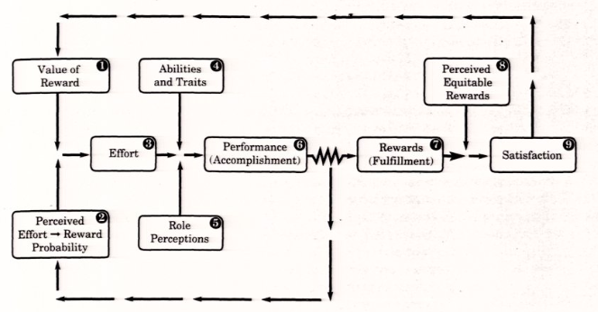

### A comparison of motivation theories

Problem with Process Theories

Often leave the person lost in thought(not that rational)

People ignore their best interests(ignore the best behavior)

Often based on perceptions (not equal to reality and can change)

No specific predictions(too many variables)

| Theory | Cognitive Load | Behavior Specificity | Research Support | Practical Application |
| --- | --- | --- | --- | --- |
| Manifest Needs | low | moderate | low | low |
| Need Hierarchy | low | low | moderate | low |
| ERG theory | low | low | moderage | low |
| Two Factor | low | low | moderate | moderate |
| NAch | low | moderate | high | moderate |
| Reinforcement | moderate | high | high | high |
| Goal Setting | high | moderate | high | high |
| VIE Theory | high | high | high | moderate |
| Cognitive Dissonance | high | low | moderate | moderate |
| Equity | high | low | high | moderate |
| Cognitive Evaluation | moderate | low | moderate | low |
| Expanded VIE | high | moderate | moderate | moderate |

### Applications of Motivation Theories

Management by Objectives (MBO) set the goal → review the goal

Job Enrichment/Design design work to motivate people

Behavior Modification making more clear about the results of specific behavior

Compensation/Rewards EG. pay for skill => more flexibility EG attendance poker

## Attitude

### Important work attitudes

#### Job Involvement

Definition

There is no agreement on exactly what it is

It is multidimensional

Most ideas revolve around personal identification with one or more aspects of work

eg. highly involved people know their role in the org

losing job for them = losing identity, but they are intrinsic motivation

A good example of how we have to be careful with definitions

*Measurement*

*1. I’ll stay overtime to finish a job, even if I’m not paid for it. (HIGH)*

*2. You can measure a person pretty well by how good a job s/he does.*

*3. The major satisfaction in my life comes from my job.*

*4. For me, mornings at work really fly by.*

*5. I usually show up for work a little early, to get things ready.*

*6. The most important things that happen to me involve my work.*

*7. Sometimes I lie awake at night thinking ahead to the next day.*

*8. I’m really a perfectionist about my work.*

*9. I feel depressed when I fail at something connected with my job.*

*10. I have other activities more important than my work. (LOW)*

#### Organizational Commitment

Definition (related to org instead of the job)

Company loyalty BUT committed people expect the commitment back

Acceptance of the organization’s goals and values

A willingness to exert effort on behalf of the organization

A desire to remain with the organization

*Measurement*

*1. 1 am willing to put in a great deal of effort beyond that normally expected in order to help this organization be successful.*

*2. 1 talk up this organization to my friends as a great organization to work for.*

*3. 1 feel very little loyalty to the organization. (R)*

*4. 1 would accept almost any type of job assignment in order to keep working for this organization.*

*5. 1 find that my values and the organizations values are very similar.*

*6. 1 am proud to tell others that I am part of this organization.*

*7. 1 could just as well be working for a different organization as long as the type of work was similar. (R)*

#### Positive Dispositional Affect(New)

Definition

A person’s mood

A predisposition to be happy and feel good(generally happier and more satisfied)

More of a trait than a state (trait is more stable)

Your attitudes can change from job-to-job but this probably does not

#### Job Satisfaction

Definition

Feelings and attitudes one has about one’s job

A composite of all the feelings – Overall

Feelings and attitudes about a number of different elements of the job – Facet

Common Facets = Work, Pay, Supervision (might misleading if only look at the overall)

Measurement

Job Descriptive Index (JDS) comparing satisfaction to other orgs. 6 scale

Minnesota Satisfaction Questionnaire (MSQ) good for managers to figure out employees’ satisfaction and what to improve. 20 scale

Need Satisfaction Questionnaire (NSQ) related to the need theories.(3Q)

how much of the need is fulfilled in my job?

how much should there be?

how important is it?

Faces Scale: describing your emotions

### Job Satisfaction Theories

Facet Theory – Lawler

Mixture of three issues

Expectancy = how much sth is and how much it should be.

Equity = is it equitable?

Discrepancy = difference in expectancy. Bigger difference => problem

Can be different for each facet of the job

Social Influence

People do not want to think EG. should I be happy?

Look at others to determine attitude facet theory requires more thinking

Opponent Process Theory – Landy

We seek to maintain neutral emotions being angry/happy requires more energy

Strong emotion needs to be offset we want to stay as neutral/natural(being myself) as possible. being yourself instead of being forced positive

### Job Satisfaction Individual Differences

Negative Affectivity: sb is more negative than others in general

Age: younger => less satisfaction

Education: more educated => less satisfaction

Gender: no differences. female is less

Ethnicity & Culture: minority is less satisfied.

### Importance of Satisfaction

#### Relationship between satisfaction and commitment

They are correlated(+) but distinct

May be due to measures and avoidance of dissonance

Both probably driven by other things

Overall declines in both due to downsizing

Real value is that they may lead to OCB(Org Citizenship Behavior = doing things you don’t have to do)

#### Relationship between satisfaction and job performance

A moderate positive correlation

direct relationship between performance & reward => high job performance and satisfaction

Relationship may be indirect

#### Relationship between satisfaction, commitment, absenteeism and turnover

Model of work motivation and job performance: P = f (M, A, K, E)

motivation motivation is necessary but not sufficient to performance

ability

knowledge

environment

indirect relationship between attitudes and turnover

## Quiz 14-19 [quizlet](https://quizlet.com/126468509/psy-307-quizzes-14-19-flash-cards/)

The channel is the ____ the message takes.

**a. route**

b. package

c. language

d. pipe width

e. all of the above

One disadvantage of the chain channel of communication is _____.

a. information can be distorted

b. dependent on weakest link

**c. both a and b**

d. speed

e. distance traveled

All of the following are elements of communication except _____.

**a. process**

b. sender

c. message

d. channel

e. feedback

All of the following are barriers to communication except _____.

a. censoring

b. overload

c. filtering

**d. winking**

e. diversion

Encoding language involves _____.

a. spoken

b. written

c. unspoken

d. nonverbal

## **e. all of the above**

## Quiz 15

Sociometry is a method of studying the ____ of groups.

a. communication

b. likes

c. dislikes

**d. both b and c**

e. none of the above

The purpose of an informal group is to _____.

a. perform needed organizational tasks

**b. share a common interest**

c. be sanctioned by the formal organization

d. isolatae individuals

e. none of the above

Which of the following would involve the least work group participation?

**a. quality circle**

b. autonomous work group

c. decision making task force

d. product design team

e. none of the above

One risk of a highly cohesive group is _____.

a. communication

b. social striving

c. role ambiguity

d. masking

**e. none of the above**

You can reduce the level of conflict in groups by introducing a _____ goal.

a. difficult

**b. superordinate**

c. specific

d. long term

e. all of the above

## Quiz 16

Motivation involves the ____, ____, and ____ of behavior.

a. velocity, speed, direction

b. amplitude, vigor, persistence

c. direction, persistence, resistance

**d. direction, persistence, vigor**

e. none of the above

Motivation theory can be broken down into ____ and ____ theories.

a. valence and needs

**b. content and process**

c. needs and cognition

d. systems and process

e. none of the above

The two factors in Hertzberg's two-factor theory are _____ and _____.

a. satisfiers and motivators

**b. hygiene factors and motivators**

c. hygiene factors and dissatisfiers

d. self-fulfillers and motivators

e. none of the above

According to Alderfer, growth needs are different that other needs because the more the growth needs are satisfied _____.

a. the less they will be desired

b. the more they will be rejected

c. the more the remaining needs will be desired(Maslow)

d. the less the remaining needs will be desired

**e. none of the above**

Horizontal loading is _____.

**a. giving more tasks in a sequence or process to the worker**

b. giving fewer tasks in a sequence or process to the worker

c. giving managerial tasks to the worker

d. giving worker tasks to the manager

e. all of the above

## Quiz 17

According to equity theory, people are motivated to ____.

a. contribute considerably more work input than they receive in rewards

**b. maintain a balance between their work input and the rewards they receive**

c. contribute slightly less in work input than they receive in rewards

d. contribute slightly more in work input than they receive in rewards

e. maximize rewards no matter what the input

Which of the following theories underlies the concept of Management by Objectives?

a. intrinsic motivation theory

b. reinforcement theory

**c. goal setting theory**

d. expectancy theory

e. equity theory

The expectancy component of expectancy theory refers to _____.

a. the anticipated satisfaction of a particular outcome would bring to the individual

b. the perceived degree of relationship between performance and outcome

**c. the perceived degree of relationship between effort and performance**

d. the amount of effort the person will exert

e. none of the above

Linking pay to performance may motivate because _____.

**a. it increases instrumentality**

b. it increases valence

c. it increases expectancies

d. it reduces effort

e. none of the above

Behavior modification is best as making clear _____.

a. desired cognitions

**b. desired behavior**

c. valued outcomes

d. degree of effort required

e. all of the above

## Quiz 18

Job satisfaction is defined as _____.

a. the positive feelings one has about one's job

b. the negative feelings one has about one's job

c. the neutral feelings one has about one's job

d. the positive and negative outcomes from one's job

e. the positive and negative feelings one has about one's job C

Most job involvement definitions include _____.

a. personal identification with one or more aspects of work C

b. a sense of accomplishment from the job

c. sharing the goals and objectives of the organization

d. the positive and negative feelings from one's job

e. none of the above

Meta-analysis studies have indicated that job satisfaction and job performance _____.

a. are strongly positively related to each other

b. are strongly negatively related to each other

c. are moderately negatively related to each other

d. are moderately positively related to each other C

e. show no relationship at all

The best predictor of someone quitting their job is _____.

a. thinking of quiting

b. job satisfaction

c. intention to search

d. intention to quit/stay C

e. probability of finding an acceptable alternative

According to the social influence theory of job satisfaction _____.

**a. a person's satisfaction is determined by his or her perceptions of how other people feel about the job**

b. one's job attitudes are not affected by most other people on a select few

c. the amount of job satisfaction depends on one's level of expectation

d. job satisfaction is determined by the primary and opposing response to a stimulus

e. none of the above

## Quiz 19

The theory was MOSTLY about _____.

a. need for achievement C

b. need for power

c. need for affiliation

d. none of the above

e. all of the above

The theory indicates that people are ____ about their need for achievement.

a. aware

b. unsure

c. not aware C

d. none of the above

e. all of the above

The theory says that people can _____ need for achievement.

a. be trained

b. learn

c. not be aware of their

d. all of the above C

e. none of the above

The technical was mostly about _____.

a. the numberical results

b. positive findings

c. written comments C

d. all of the above

e. none of the above

Attitudes survey used ____ to help interpret the results of the comments.

a. coders C

b. psychologists

c. managers

d. pilots

e. mechanics

# Block 4

## Power

Definitions

Influence = use of social forces(eg. peer pressure, expectations) to affect behavior (not necessarily formal)

Power = use of work relationship to affect behavior despite resistance (likely to be more formal)

eg. chief (accepted)

Politics = use of personal behavior to influence others to reach goals (may be personal goals)

Influence and Power are related. Politics is related to personal behaviors

Types of Influence

Assertiveness (pros/cons <= context): leadership, initiative, making rules, interrupting

“I think we should do this”

Ingratiation wins: nice, polite, opposite of assertive (they are trying to make someone do sth)

Rationality (not so much): rational, reasoning, logical, BUT not know the people’s need

not really good at influence eg. “How this influences me?”

Sanctions: threats, punishments to avoid bad things happen

* Preference but no general tendency (switch if one doesn’t work). Higher position = more assertive and sanction. Lower position = rationality. Coworker = ingratiation.

Exchanges: to meet both side’s need

Upward Appeals: borrow one power and sale them

Blocking: slowing things down to avoid/ignore something dislike

Coalitions: form groups (human win the natural selection process by collaborating)

eg. Alpha male/female = dominating person

Resisting Attempts to Influence

Best way to combat them is to recognize them

Be aware of weird questions

EG. You are not looking good today and you have not lost weight!

Answer questions with questions: Why do you ask?

cognitive consistency = humans are motivated by inconsistencies and a desire to change

Common Influence Strategies in sales

Reciprocity rule = social situations we pay back what we received from others

Commitment and consistency rule: relate the work to some committed rule/belief

EG. “Do you believe in ….? then you should do this”

Scarcity principle: “this is the last one”, “you should plan wisely and we don’t have...”

Guilt principle: “can I get 100 dollars? can I get 20 dollars?”

Promoting Liking through Ingratiation

Types and Bases of Power

Types of Power

Organizational Power: by title (EG. Directors can sign the contract)

Individual Power: not related to org

Increment in Influence

Power (given), Authority (given), Leadership (make sb want to do sth)

Bases of Power

Coercive (punishment)

Reward

Legitimate (position)

Expert: generated by self (EG. journals, papers, degree)

Referent: identifying/finding the relationship between you and others (build linkages)

* leadership uses more expert & referent bases

Measuring Power

Instruction and Anchors (level of each base)

Items (different bases)

Power Dynamics (opinion, why people are using it? for personal/company purpose?

Power Differences: some companies want more than others

Increasing Power of their own

Dependency: not want to be a dependent position

Work Outcomes may affect someone else’s job

Power Corollary: trade-offs

Leadership

Empowerment - Giving worker a sense of control and efficacy by:

Expressing confidence and high standards

Involving in decision-making

Increasing autonomy

Setting inspirational and meaningful goals

Use position power sparingly (not use power explicitly)

Types of Organizational Politics

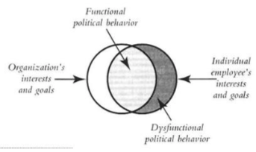

functional behavior is the overlap which is the desired part

individual interest = dysfunctional behavior (use org as an excuse to meet personal needs)

org interest is not separated with individuals in real life

* senior employees maybe cannot separate individual and org interest

The function of Organizational Politics

Competition for power and resources (to get more power/resources)

Posturing for subjective evaluation systems (higher evaluation => more resources)

new employees get credits: help others with their jobs OR others are doing sth wrong

Delaying of evaluation for long-term tasks (not meeting deadlines => shifting responsibility)

Compensating for shortcomings (more power => find someone to do sth I am not good at)

Because of no group interdependence (commonality => harmony, independence => competing)

To impact decision making (annual evaluation => benefit)

EG. inflation <= expectation

EG. Degree of political behavior:

Good(positive win-win) - Bad(negative but true, avoiding) - Ugly(false negative, rioting)

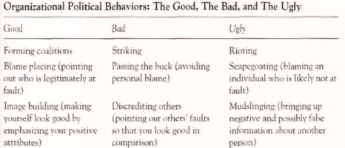

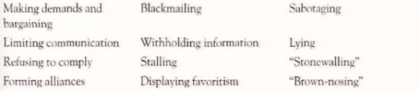

Contingency approaches to power

Organizational Life Cycle Model

New organizations are run by all powerful founders (power => build good relationship)

Older organizations involve more bargaining and exchange (power are distributed along time)

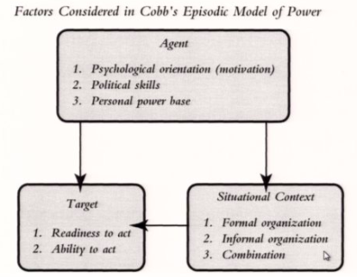

agent has certain motivation/opinion

target might be mistargeted (can they act? will they act?)

context => target (formal is about title, informal is about expertise)

Dealing with Organizational Politics

Remove ambiguity and uncertainty (about the goal, who is in charge)

Provide “slack” resources

Create a positive organizational climate (attitude influences others)

Clarify selection and appraisal processes (ambiguity & uncertainty)

Reward performance not political skill (reward who produce the outcome)

Symbols of Power

Personal

Clothing: suit shoes (EG. not wearing suits is also a way to project power)

Jewelry: watch

Cars: powerful people can twist the rules

Assistants

Housing

Organizational

Office (size, materials, desk, chair, door opening, windows, building location)

Club Memberships

Difficulty to contact

Jet

Entourage

## Leadership

Definition

Influence: not tied to the title

Position: title/responsibility but may not really lead

Effectiveness: not confer/determine until after the affect (criticism during leading process)

Traits/Behaviors/Situations: getting people to make extra efforts

(Great Man/Woman: by genes/privileges/education?

Leaders are born

Leadership can not be taught

Leadership runs in certain families

)

Trait Theory => selection

Evidence:

Physical - leaders are more physically attractive (eg. taller)

Gender/Race - white males (privilege/barriers) Questionable

Intelligence

too bright => barrier between you and follower

below average => not convincing

Personality

Taking risks (gambling)

Achievement & influence (power motive)

(The big five Personality Theory

Extraversion, conscientiousness (a desire to do a task well) more, openness to experience more, agreeableness, emotional stability (maybe less)

)

Flexibility (open to new idea), charisma, social intelligence (connect to others)

Application

Select leaders based on traits

Problems

Successful leaders are remarkably varied (many counterexamples)

Personality easy to fake (how to measure?)

Behavioral Style Theory => training

Evidence:

Manager Behaviors

lower manager - supervising

senior manager - planning/analyzing (introvert)

Styles:

democratic/participative: listen to the group and majority win

autocratic: make decisions on their own (usually works better and saves time)

initiating structure / task-oriented behaviors

assign tasks and steps or only set the big goal

new task needs initiation, familiar tasks don’t need initiation

Consideration / relationship-oriented behavior

aware of the situation of the “life”

autocratic leaders are less likely to be considerate

Application

Train managers how to behave

Problems

Behavior is often complex and interactive (how and when ...)

Research is cross-sectional (environment)

Perceptions of behavior is what matters (behavior VS perception)

Situation Theory => redesign work environment

Situation - Leader Behavior

Competence of followers => confidence

Complexity of task to be performed => more initiating structure and more supportive

Initiative of subordinates

Leader attributions of performance problems (shift responsibility)

Situation - Effectiveness (shift responsibility, success is put on the leader)

Context may drive performance more than leadership

For leaders to have an impact, the situation has to be critical or made so

Effectiveness - Causality

Leaders get both the blame and the credit

Impression management is important (fired when things go wrong)

Everyone suffers from an attribution paradox

Application

Redesign the work environment (how people relate to each other)

Problems

Many leaders “rise above” the situation

Situation can neutralize or provide substitutes (open environment is better)

Formal organizations harder to influence

Contingent Theories of Leadership (match the demand of the situation)

Fiedler’s Contingency Theory: change between task/relationship oriented behaviors

Favorable situation to lead (highly favorable/unfavorable is not successful)

Leader-member relations: trust/confidence level (LPC)

Task structure: vague/clear, un/structured

Position power: reward/punishment

LPC(least-preferred-coworker) Questionnaire: task-oriented leaders get lower score

Path-Goal Theory

specifying a leader's style or behavior that best fits the employee and work environment in order to achieve a goal

VIE(motivation theory) applied to leadership (behavior leads to success? success leads to desired outcome? how desirable is the outcome?)

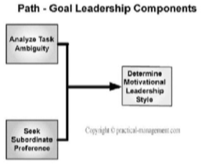

Major Components

(Situational) Leadership Style (eg. coaching, directing, participating)

Subordinate Preference: how followers perceive the leadership? satisfied? stressful?

Task Structure: analyzing tasks & reformulating the structure in a clear way

Motivation of Subordinates

Direction about the expectations (when they are new/unsure)

Support: showing concern + approachable ( when tasks are physically/psy challenging)

Participation: consult the followers about the taks (when followers are highly trained)

Achievement Orientation: set the goal (in professional/achievement work environment)

Vroom and Yetton Decision Model Based on decision making tree

Decision Tree Questions

Is a high quality decision required?

Does the leader possess sufficient info to make a high quality decision?

Is the problem structured?

Is acceptance by subordinates crucial for effective implementation of the decision?

Will subordinates accept the decision if the leader makes it alone?

Do subordinates share organizational goals?

Is the preferred solution likely to cause conflict among subordinates?

Decision Tree

1. Autocratic Decision

1- Make decision alone using information available only to the leader

2- Make decision alone but use information from subordinates

3. Consultative Decision

1- Make decision alone but share problem with relevant subordinates and get ideas and input individually

2- Make decision alone but share problem with subordinates as group and gets collective input

5. Group Decision: The leader shares problems with group and together they make the decision

A comparison of contingency theories

| Theory | Traits | Behavior | Situation |
| --- | --- | --- | --- |
| Consistency Theory | y | y | y |
| Path Goal Theory | n | y | y |
| Decision Making | n | y | y |

Application of Contingency Theory

Application

Selection

Training to be good leaders

Redesign work environment

Problems

Often complex and hard to understand

Suggest too much thought

May be more prescriptive rather than descriptive

New Theories of Leadership

Charismatic Leadership Theory

Leader Characteristics

Communicate vision and goals, self-confident, believe in followers

Ability to Inspire

Desire to change, innovate, and take risks

Sensitive to followers and situation

Follower Characteristics

Identify with leader

Emotionally susceptibility

Desire for Change and Growth

Situational Circumstances

Uncertainty, ambiguity and risk

Opportunities for growth, change, or innovation

Transactional

Relationship between leader and follower based on exchange

Leader figures out what followers want

Leader makes follower’s desired outcomes contingent on behavior/results

Transformational

Leader changes beliefs and values of followers by:

Identify and articulate a vision

Provide an appropriate model

Foster an acceptance of group goals

Leader changes beliefs and values of followers by:

Maintain high performance expectations

Provide individualized support

Provide intellectual stimulation

Future of leadership research:

Dynamic Environments

Global Competition and Operations

Expert Systems

(How to “Manage” Perceptions

Have others announce bad news but always announce good news yourself

Dress for success (this is getting harder to do because of changing workplace)

Repeat what others say and encourage them to talk

Focus on “quick wins” at first

“Stand up” for your people

Always act very busy

)

## Organizational Theory

Definition

Structure

Human Relations

Process

Environment

What is organizational theory?

Macro versus Micro

Macro = organization as a whole

Micro = individuals and groups

Historical Development

Large Organizations are new

Growth led to new problems

Two key schools of thought

Scientific Management

Fredrick Taylor is founder

Work is machine like

Simple work easier to train

Efficiency leads to greater rewards

Human Relations

Elton Mayo is founder

Western Electric Hawthorne Plant

Participation increases motivation

How do organizations “behave”?

Structure

Elements of Structure

Division of Labor

Job Specialization

Span of Control

Horizontal and Vertical Differentiation

Degree of Centralization

Degree of Formalization

Structure - Bureaucracy (Weber)

Elements

Division of Labor

Hierarchy of Authority

Impersonal Handling of Labor

Rules and Policy Specified

A reaction to autocrats

Structure- Management Theory

Combined experience of practicing managers

Lists of specific principles

No overlapping authority

Authority should equal responsibility

Jobs should be clearly specified

Limited Span of control

Structure- Neoclassical Theory (Follett)

Trying to “fix” bureaucracy

Emphasis on communication

Recognition of other human needs

Structure - Technology Theory (Woodward)

Organizational Structure the result of production technology

Unit production (small batch)

Mass production (large batch)

Process production

3 Basic Problems with Structural Approach

Actual and stated organization are different

Bureaucracy is dehumanizing

Bureaucracy is rigid

How do organizations “behave”?

Human Relations

Theories X, & Y (McGregor)

Theory Z (Ouchi)

Developmental Model (Argyris)

Organizational Systems (Likert)

(Problem with behavioral approach

A reaction to bureaucracy

Better liked but not better performance

Can lead to “sham” participation

)

Process

Decision Theory

Concerned with how organizations make decisions

Are decisions rational

Contingency Model (Lawrence and Lorsch)

Managerial differentiation results from

Diversity of sub-environments

Uncertainty of environment

Differentiation reduces unity

Information Processing Theory (Gailbraith)

Organizations need to reduce uncertainty from environment

− Control environment

− Accumulate slack resources

− Restructure - Matrix

Culture Theory

Organizations behave by making culture

Culture often involves metaphors

Environment

Configurational (Mintzberg)

Three important aspects of environment

− Degree of stability

− Complexity of technological knowledge base

− Sophistication of technical system

Sociotechnical Systems

How does new technology affect work

Social aspects as important as technical

Led to greater appreciation of systems

Open Systems (Katz and Kahn)

Based on biological model

Input/Transformation Process/Output

Sustainability is important

How do organizations affect their people?

Level of Participation

No all react the same to participation

High-involvement organizations

There are five levels of participation

low participation

autocracy

bureaucracy

participation

democracy

ownership

high participation

QWL Programs

Quality Control Circles

Participative Decision Making

Self Managed Work Groups

Employee Ownership?

Organizational Culture

Organizational expectations

Socialization

Learning to “fit in”

mastery of skills

feedback process

positive interaction with superiors

How do organizations change?

Organizational Development (OD)

Four steps to OD: diagnosis, planning, action, evaluation

Common techniques

Survey feedback

Team building

Information Technology

Considerable value in collecting and transforming information

Concept of “page” is dying

Expert systems will be everywhere

The first stop is now google

## Quiz 20 - 25 [quizlet](https://quizlet.com/134197557/io-psych-exam-4-quiz-answers-20-26-flash-cards/)

_______ is usually exerted by using informal strategies such as persuasion or peer pressure.

**a. influence**

b. power

c. politics

d. all of the above

e. none of the above

Lower status organizational members, when seeking organizational goals, try to influence higher status members through the use of _____.

a. assertiveness

b. sanctions

**c. upward appeals**

d. blocking

e. none of the above

Two main types of power are _____ and _____.

**a. organizational and individual**

b. organizational and coercive

c. individual and coercive

d. integration and organizational

e. none of the above

The source of power that comes from the formal authority that an individual possesses because of his or her position in the organization is referred to as _____.

a. reward power

**b. legitimate power**

c. network centrality

d. resource control

e. all of the above

All of the following are examples of empowerment except _____.

a. expressing confidence

**b. giving direct orders**

c. involvement in decision making

d. increasing autonomy

e. expressing high standards

## Quiz 21

According to the text, how often is the use of power in organizations successful?

**a. almost always**

b. frequently

c. sometimes

d. less so now than in the past

e. none of the above

All of the following are symbols of power in organizations except _____.

a. office size

**b. job title**

c. difficulty to contact

d. club memberships

e. jet

Functional political behavior is the intersection between individual goals and _____.

a. team goals

b. individual interests

c. organizational interests

d. environmental pressures

**e. organizational goals**

All of the following are ways to deal with organizational politics except _____.

a. remove ambiguity

b. remove uncertainty

**c. reward political skill**

d. provide slack resources

e. create a positive organizational climate

A contingent view of power would argue that use of power varies as a function of _____.

a. organizational size

**b. organizational age**

c. organizational purpose

d. organizational mission

e. all of the above

## Quiz 22

The leader most likely to be supported by his/her followers is a/an _____ leader.

a. appointed

**b. emergent**

c. autocratic

d. laissez-faire

e. none of the above

Although leadership is difficult to define, most definitions include _____.

a. the number of subordinates

b. number of promotions

**c. influence over others**

d. size of paycheck

e. all of the above

Effective leadership may depend on _____.

a. the leader's personality

b. the leader's behavior

c. the situation

d. assessment of the task

**e. all of the above**

The kind of leadership theory that would stress the selection of managers is _____.

a. contingency theory

b. behavioral style

c. expectancy theory

**d. trait theory**

e. none of the above

The kind of theory that would stress the TRAINING of managers is _____.

**a. behavioral style theory**

b. trait theory

c. contingency theory

d. expectancy theory

e. all of the above

## Quiz 23

According to Fiedler's Contingency Theory, effective leadership is _____.

a. a matter of leadership style

b. dependant upon the leader's personality

c. dependant on the appropriate administration of reward and punishment

**d. a function of the characteristics of the leader and the situation**

e. the situation

Which theory suggest that effective leaders increase their subordinates perceptions that effort leads to performance?

a. Vroom-Yetton model

b. Fiedler's Contingency Theory

**c. Path-Goal Theory**

d. none of the above

e. all of the above

The method based on a decision tree is _____.

**a. Vroom-Yetton**

b. Fiedler's Contingency Theory

c. Path-Goal Theory

d. Contextual Theory

e. Trait Theory

Which of the following leadership theories draws most heavily from the VIE theory of work motivation?

**a. House's Path-Goal Theory**

b. The Vroom-Yetton Model

c. Fiedler's Contingency Theory

d. Blake and Mouton's managerial Grid

e. none of the above

Leaders of the future will face increasingly _____ environments.

**a. dynamic**

b. stable

c. certain

d. predictable

e. none of the above

## Quiz 24

The scientific management movement was most interested in _____.

a. job satisfaction

b. worker health

**c. work efficiency**

d. work motivation

e. worker traits

The Human Relations trend in organizational theory was heavily influenced by a series of studies carried out at _____.

a. Tavistock Institute

b. IBM

c. Brithish Telecom

**d. Western Electric Hawthorn Plant**

e. NCSU

Which of the following organizational theories emphasizes organizational structure?

**a. bureaucracy**

b. technology theory

c. systems theory

d. decision theory

e. Information theory

Bureaucracy was heavily criticized for _____.

a. underpaying employees

b. overpaying employees

c. absence of rules

**d. dehumanizing employees**

e. being unstable

All of the following are problems with the structural approach except _____.

**a. stated and actual organization are the same**

b. bureaucracy is dehumanizing

c. bureaucracy is rigid

d. actual and stated organization are different

e. none of the above

## Quiz 25

Which of the following organizational theories includes the concept of transformation of input into products?

a. bureaucracy

b. management theory

**c. open systems theory**

d. technology theory

e. none of the above

_________ refers to the different thinking styles of managers in different functional parts of the organization.

a. su-environment diversity

**b. managerial differentiation**

c. uncertainty

d. slack resources

e. complexity

Quality-of-work-life (QWL) programs _____.

a. mark the second stage of the industrial revolution

b. are more popular in the US than Europe

c. increase productivity but not satisfaction

**d. depend on employee participation and involvement**

e. none of the above

Which of the following is NOT part of the socialization process?

**a. employee selection**

b. mastery of skills

c. feedback process

d. positive interaction with superiors

e. all of the above

The first step in the organizational development (OD) process is _____.

**a. diagnosis**

b. unfreezing

c. Intervention

d. refreezing

e. none of the above